EXPERIMENT-1

AIM: TO MAKE A STATIC HOME PAGE OF A E-LEARNING WEBSITE USING HTML.

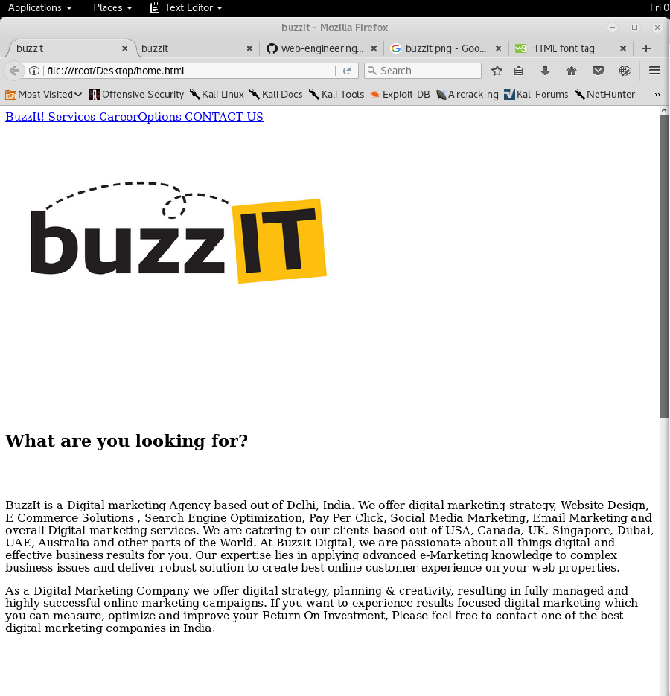

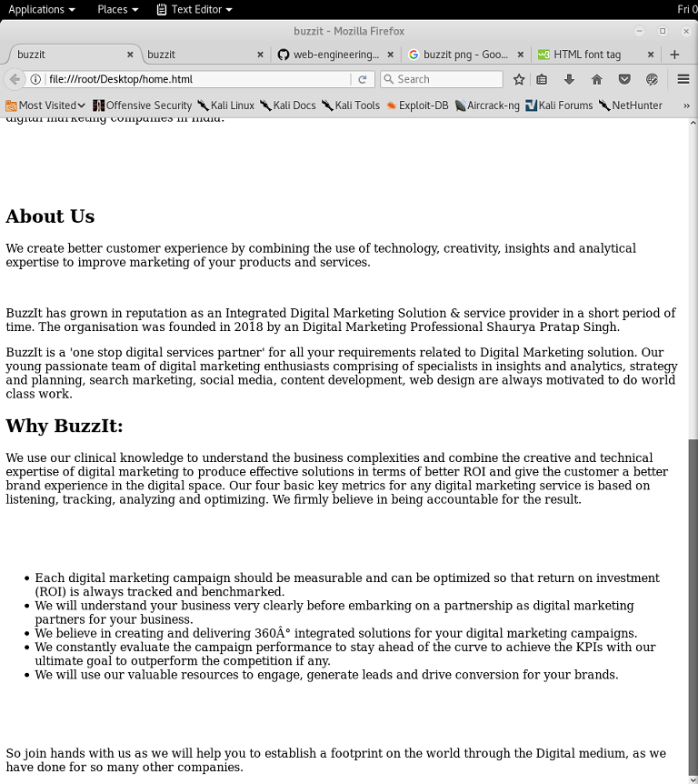

Source:

<HTML>
<HEAD>
<TITLE>buzzit</TITLE>
</HEAD>
<body>
<div class="pw" >
<a href="#"> BuzzIt! </a>
<a href="#band"> Services </a>
<a href="#tour" > CareerOptions </a>
<a href="#contact"> CONTACT US </a>
</div>
<br><br><br>
<img src="buzzitweb.jpg" height="250" width="500">
<br><br>
<font size="5" color="white" >Your Brand's Digital Marketing Performance Optimized</font>
<br><br>
<br><br>
</div>
<div class="default">
<br><br>
<h2>What are you looking for?</h2>
<br><br>
<p>BuzzIt is a Digital marketing Agency based out of Delhi, India. We offer digital marketing strategy, Website Design, E Commerce Solutions , Search Engine Optimization, Pay Per Click, Social Media Marketing, Email Marketing and overall Digital marketing services. We are catering to our clients based out of USA, Canada, UK, Singapore, Dubai, UAE, Australia and other parts of the World. At BuzzIt Digital, we are passionate about all things digital and effective business results for you. Our expertise lies in applying advanced e-Marketing knowledge to complex business issues and deliver robust solution to create best online customer experience on your web properties.</p>
<p>As a Digital Marketing Company we offer digital strategy, planning & creativity, resulting in fully managed and highly successful online marketing campaigns. If you want to experience results focused digital marketing which you can measure, optimize and improve your Return On Investment, Please feel free to contact one of the best digital marketing companies in India.</p>
<br><br>
<br><br>
<h2>About Us</h2>
<p>We create better customer experience by combining the use of technology, creativity, insights and analytical expertise to improve marketing of your products and services.</p>
<br>
<p>BuzzIt has grown in reputation as an Integrated Digital Marketing Solution & service provider in a short period of time. The organisation was founded in 2018 by an Digital Marketing Professional Shaurya Pratap Singh.</p>
<p>BuzzIt is a &#39;one stop digital services partner&#39; for all your requirements related to Digital Marketing solution. Our young passionate team of digital marketing enthusiasts comprising of specialists in insights and analytics, strategy and planning, search marketing, social media, content development, web design are always motivated to do world class work.</p>
<h2 >Why BuzzIt:</h2>
<p>We use our clinical knowledge to understand the business complexities and combine the creative and technical expertise of digital marketing to produce effective solutions in terms of better ROI and give the customer a better brand experience in the digital space. Our four basic key metrics for any digital marketing service is based on listening, tracking, analyzing and optimizing. We firmly believe in being accountable for the result.</p>
<br><br><br>
<ul>
<li>Each digital marketing campaign should be measurable and can be optimized so that return on investment (ROI) is always tracked and benchmarked.</li>
<li>We will understand your business very clearly before embarking on a partnership as digital marketing partners for your business.</li>
<li>We believe in creating and delivering 360° integrated solutions for your digital marketing campaigns.</li>
<li>We constantly evaluate the campaign performance to stay ahead of the curve to achieve the KPIs with our ultimate goal to outperform the competition if any.</li>
<li>We will use our valuable resources to engage, generate leads and drive conversion for your brands.</li>
</ul>
<br><br><br>
<p>So join hands with us as we will help you to establish a footprint on the world through the Digital medium, as we have done for so many other companies.</p>

</div>
</body>

</HTML>

EXPERIMENT-2

AIM: INSTALLATION OF XAMPP SERVER.

XAMPP is a free and open source cross platform web server solution stack package developed by Apache Friends, consisting mainly of the Apache HTTP server, MariaDB database, and interpreters for scripts written in the PHP and perl programming languages. XAMPP stands for Cross-Platform (X), Apache (A), MariaDB (M), PHP (P) and Perl (P). It is a simple, lightweight Apache distribution that makes it extremely easy for developers to create a local web server for testing and deployment purposes. Everything needed to set up a web server – server application (Apache), database (MariaDB), and scripting language (PHP) – is included in an extractable file. XAMPP is also cross-platform, which means it works equally well on Linux, Mac and Windows.

Installation:

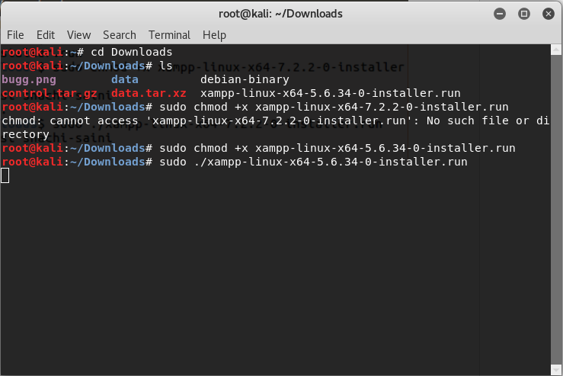
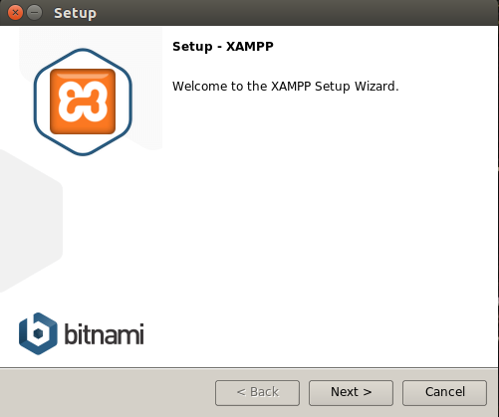

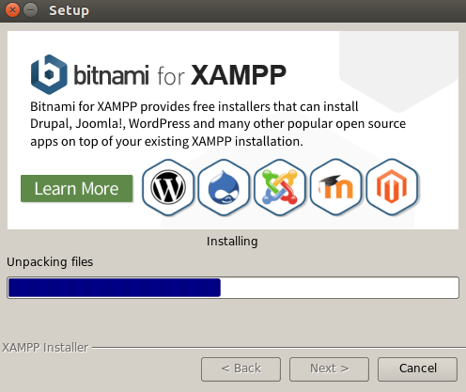

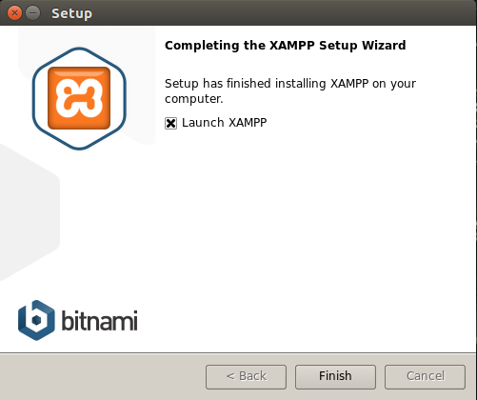

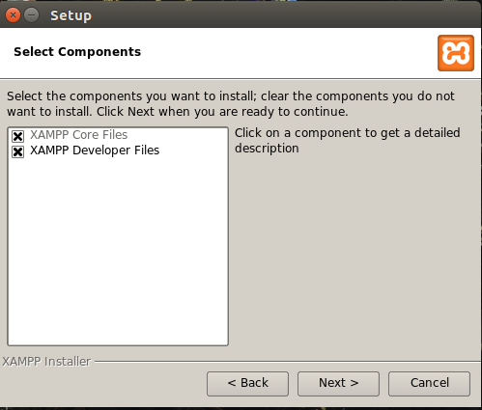
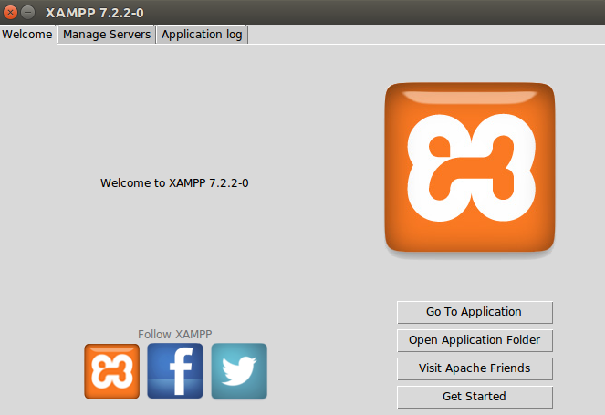
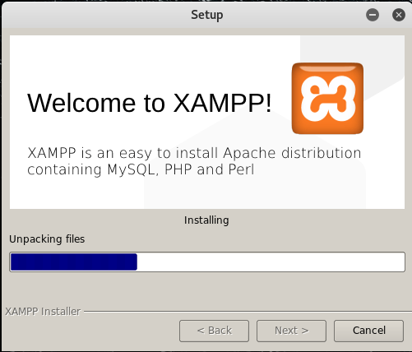

EXPERIMENT-3

AIM: TO ADD HEADER, FOOTER AND CSS TO EXISTING HOMEPAGE.

HEADER:

FOOTER:



CSS:

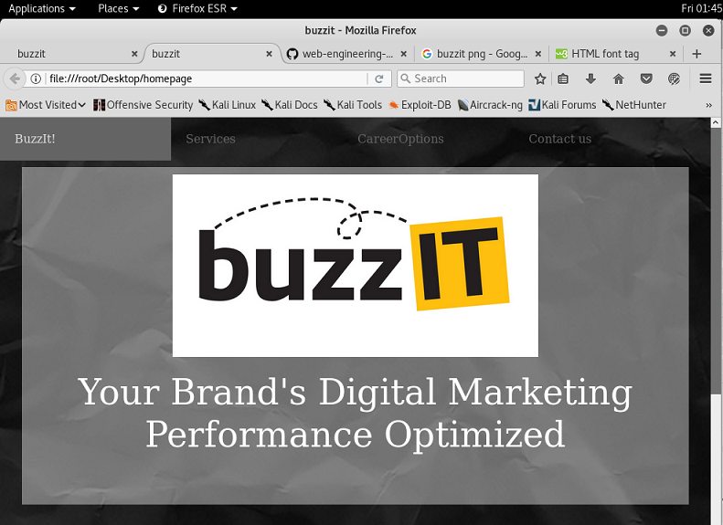



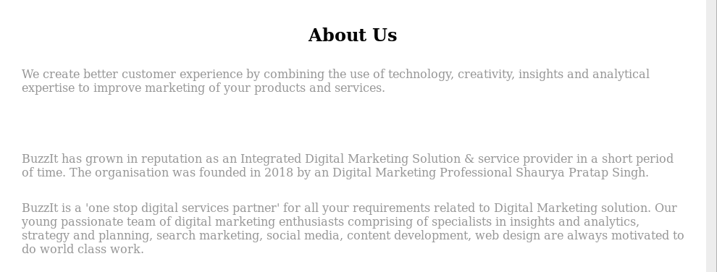
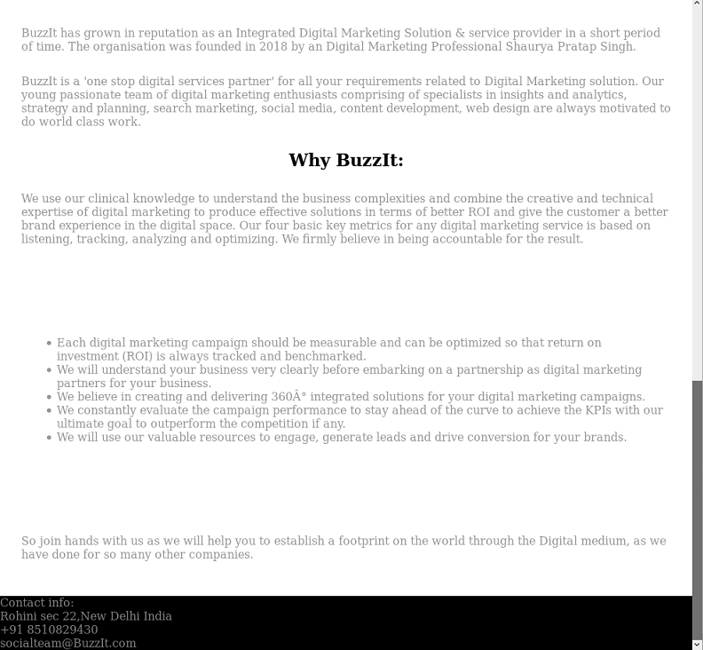

EXPERIMENT-4

AIM: TO ADD LINKS AND LIST TO WEBPAGE.

LINKS:

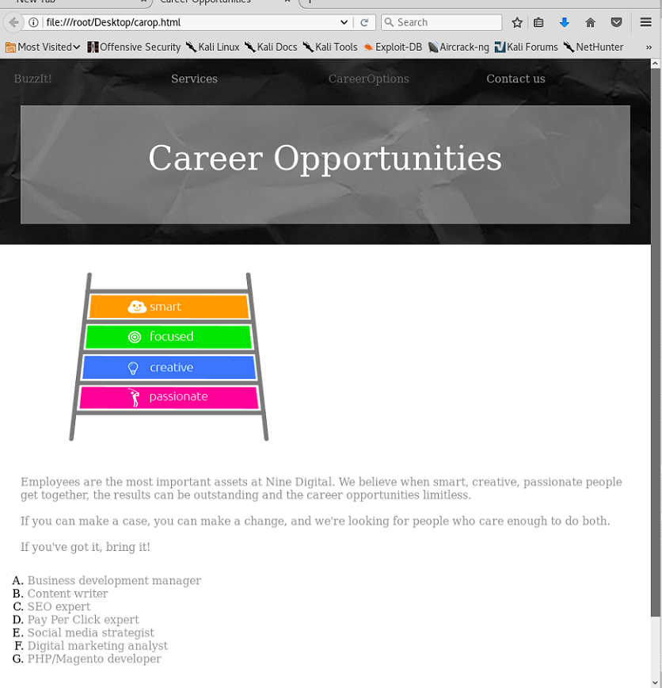

LIST-

- ORDERED LIST



- UNORDERD LIST

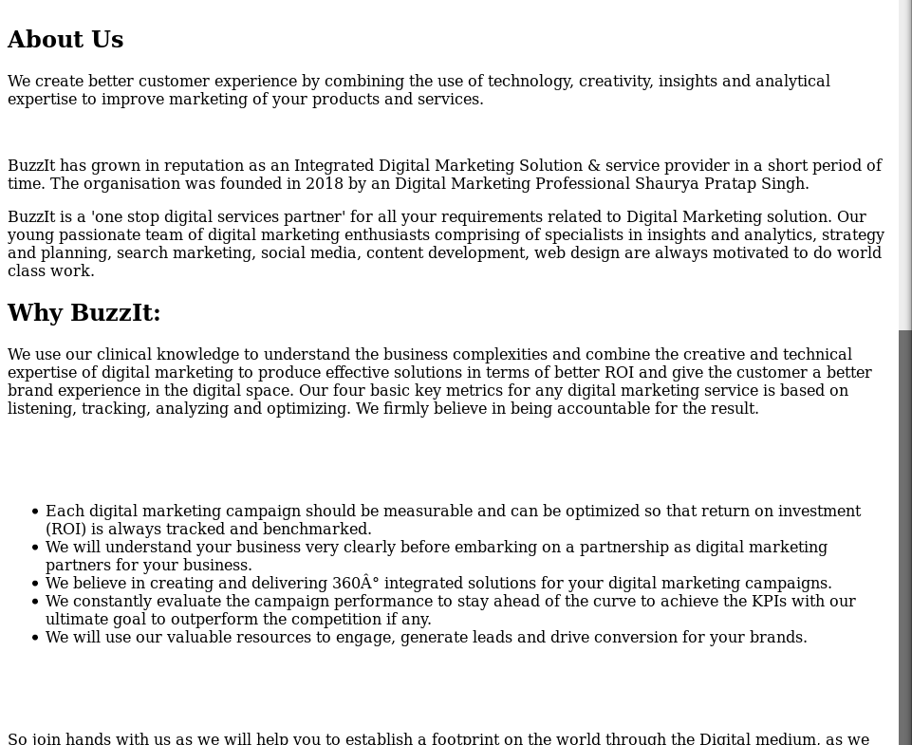

EXPERIMENT-5

AIM: TO ADD A MENU TO WEBPAGE.

CODE:
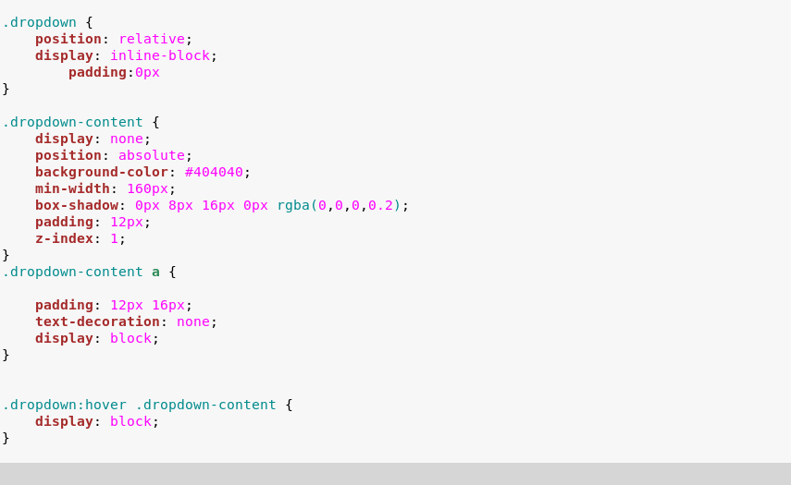

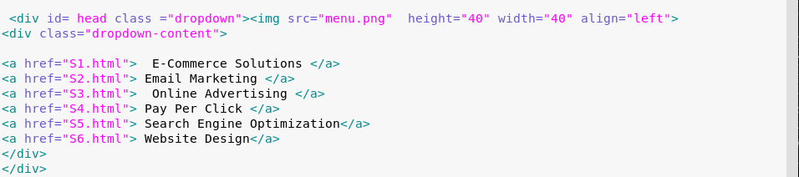

OUTPUT:

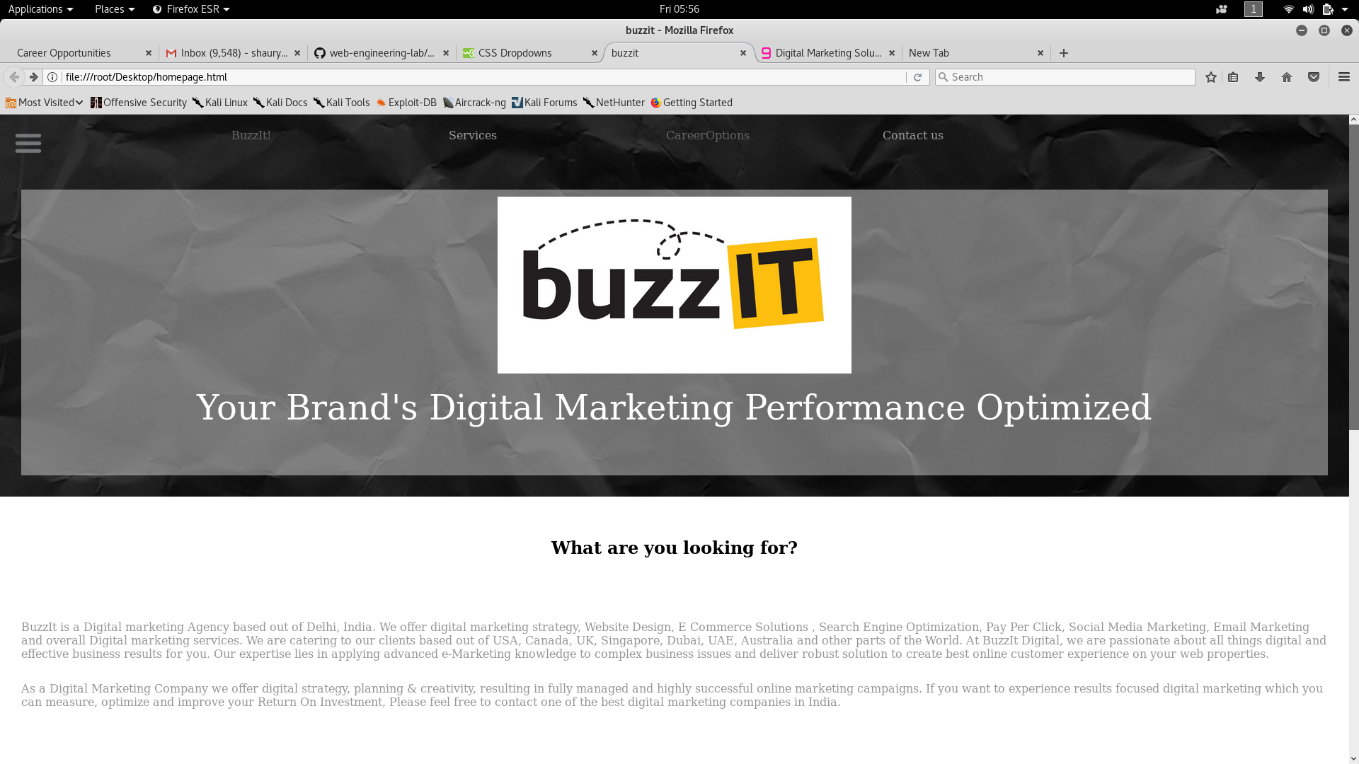

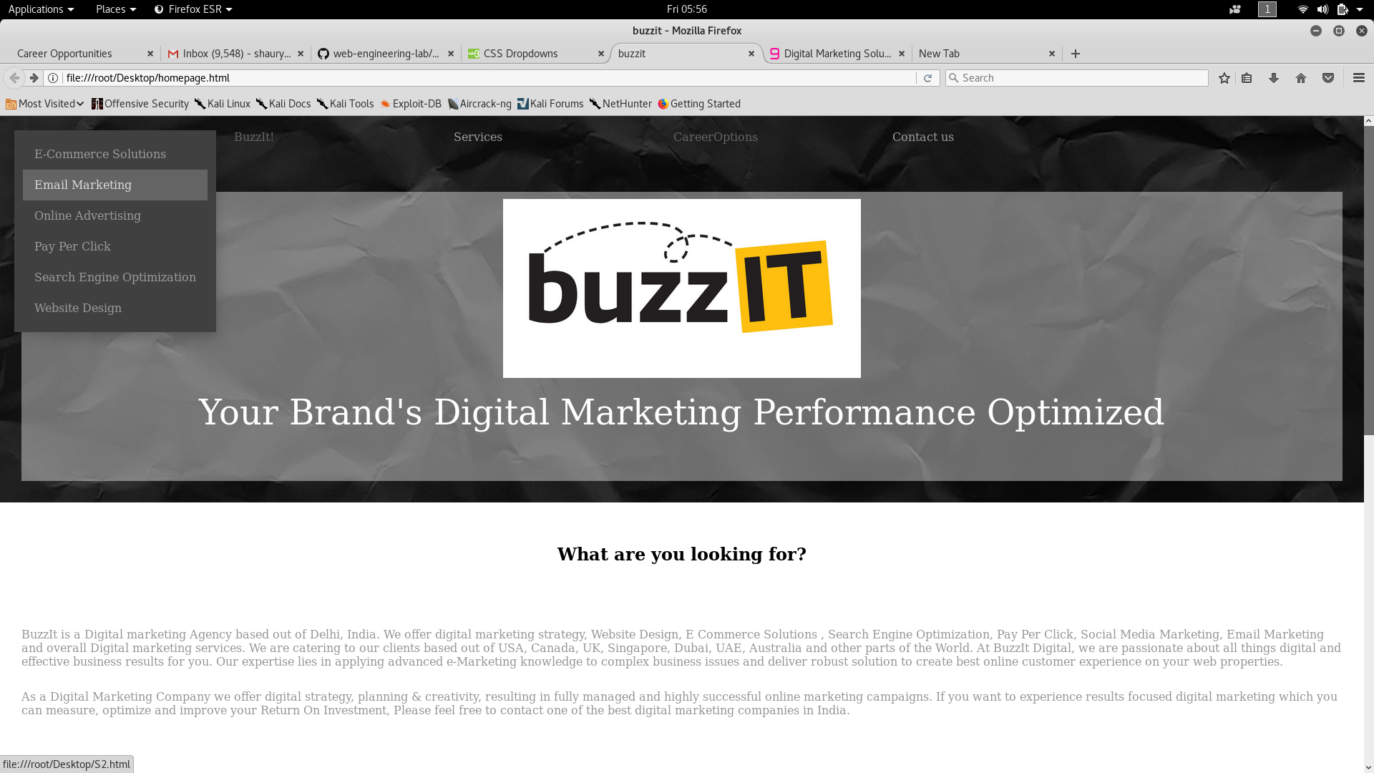

EXPERIMENT-6

AIM: TO CREATE A HTML FORM.

HTML Forms are required, when you want to collect some data from the site visitor. For example, during user registration you would like to collect information such as name, email address, credit card, etc.
A form will take input from the site visitor and then will post it to a back-end application such as CGI, ASP Script or PHP script etc. The back-end application will perform required processing on the passed data based on defined business logic inside the application.
There are various form elements available like text fields, textarea fields, drop-down menus, radio buttons, checkboxes, etc.
The HTML <form > tag is used to create an HTML form and it has following syntax −

- <input>
- <textarea>
- <button>
- <select>
- <option>
- <optgroup>
- <fieldset>
- <label>

CODE:

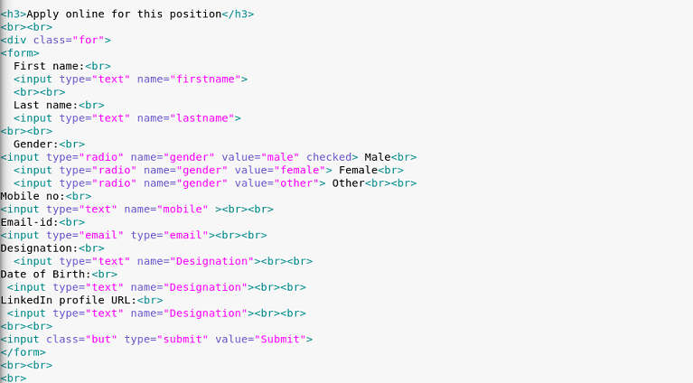

OUTPUT:

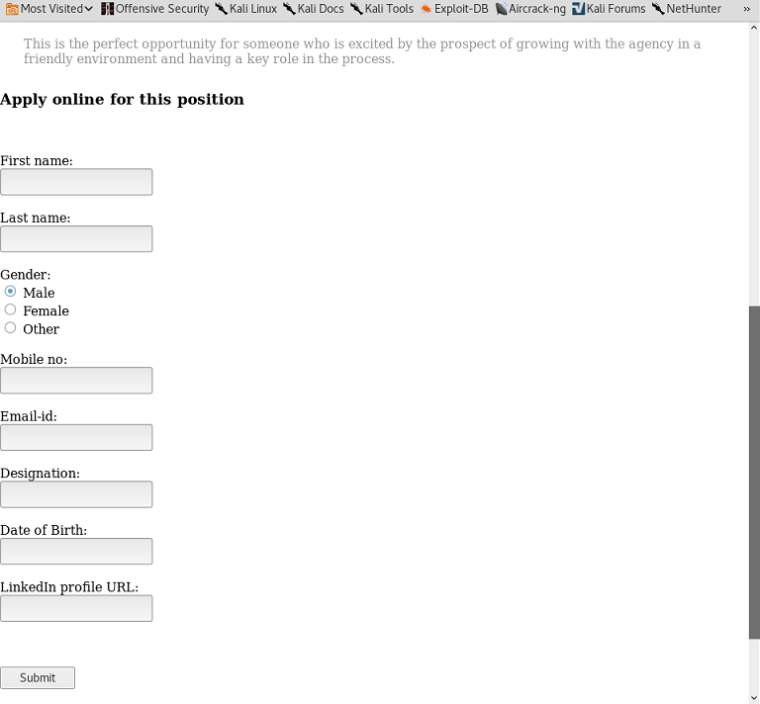

EXPERIMENT-7

AIM: ADDING JSP TO HTML FORM.

JavaServer Pages (JSP) is a technology for developing Webpages that supports dynamic content. This helps developers insert java code in HTML pages by making use of special JSP tags, most of which start with <% and ends with %>.

A JavaServer Pages component is a type of Java servlet that is designed to fulfill the role of a user interface for a Java web application. Web developers write JSPs as text files that combine HTML or XHTML code, XML elements, and embedded JSP actions and commands.

Using JSP, you can collect input from users through Webpage forms, present records from a database or another source, and create Webpages dynamically.

JSP tags can be used for a variety of purposes, such as retrieving information from a database or registering user preferences, accessing JavaBeans components, passing control between pages, and sharing information between requests, pages etc.

Why Use JSP?
JavaServer Pages often serve the same purpose as programs implemented using the Common Gateway Interface (CGI). But JSP offers several advantages in comparison with the CGI.
- Performance is significantly better because JSP allows embedding Dynamic Elements in HTML Pages itself instead of having separate CGI files.
- JSP are always compiled before they are processed by the server unlike CGI/Perl which requires the server to load an interpreter and the target script each time the page is requested.
- JavaServer Pages are built on top of the Java Servlets API, so like Servlets, JSP also has access to all the powerful Enterprise Java APIs, including JDBC, JNDI, EJB, JAXP, etc
- JSP pages can be used in combination with servlets that handle the business logic, the model supported by Java servlet template engines.

CODE:

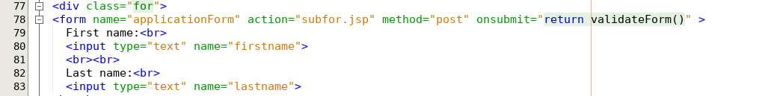
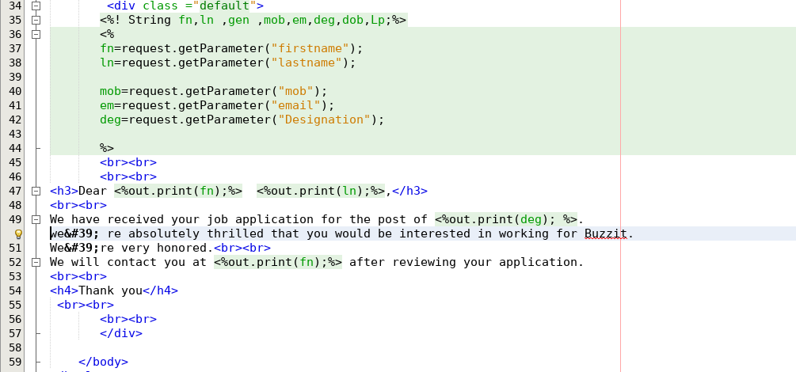

OUTPUT:

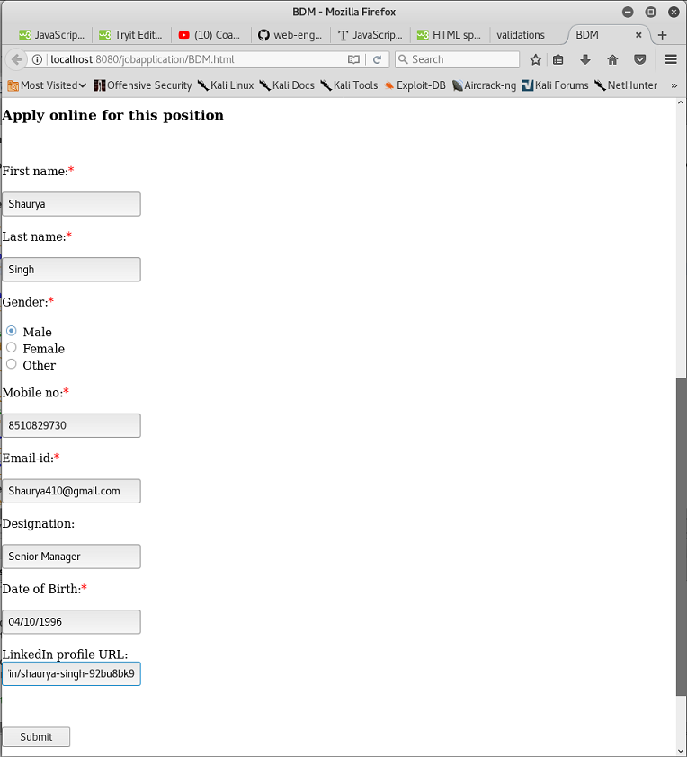

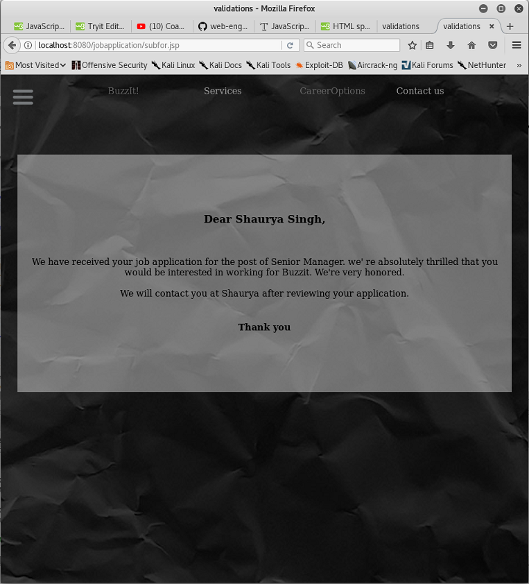

EXPERIMENT-8

AIM:ADDING VALIDATIONS TO HTML FORM

FIELD REQUIRED VALIDATION:

OUTPUT:

EXPERIMENT-9

AIM: To use XSLT stylesheet to display data in XML file on webpage.

XML stands for Extensible Markup Language and is a text-based markup language derived from Standard Generalized Markup Language (SGML). This tutorial will teach you the basics of XML. The tutorial is divided into sections such as XML Basics, Advanced XML, and XML tools. Each of these sections contain related topics with simple and useful examples.
XML tags identify the data and are used to store and organize the data, rather than specifying how to display it like HTML tags, which are used to display the data. XML is not going to replace HTML in the near future, but it introduces new possibilities by adopting many successful features of HTML.
There are three important characteristics of XML that make it useful in a variety of systems and solutions −
- XML is extensible − XML allows you to create your own self-descriptive tags, or language, that suits your application.
- XML carries the data, does not present it − XML allows you to store the data irrespective of how it will be presented.
- XML is a public standard − XML was developed by an organization called the World Wide Web Consortium (W3C) and is available as an open standard.
XSLT
Before learning XSLT, we should first understand XSL which stands for EXtensible Stylesheet Language. It is similar to XML as CSS is to HTML.

Need for XSL
In case of HTML document, tags are predefined such as table, div, and span; and the browser knows how to add style to them and display those using CSS styles. But in case of XML documents, tags are not predefined. In order to understand and style an XML document, World Wide Web Consortium (W3C) developed XSL which can act as XML based Stylesheet Language. An XSL document specifies how a browser should render an XML document.
Following are the main parts of XSL −
- XSLT − used to transform XML document into various other types of document.
- XPath − used to navigate XML document.
- XSL-FO − used to format XML document.

XML Document:

<?xml version="1.0" encoding="UTF-8"?>
<CareerOpportunities_menu>

<CareerOpportunities>
<name> Business development manager</name>
<vac> vacancies-3</vac>
<description>BuzzIT! is a digital agency based in New Delhi, India. We specialise in creating digital marketing solutions for web, mobile and social media to help companies engage and inspire their audiences.We are still a young agency, with a strong portfolio comprised of several high profile brands in India and Abroad. We are a small team of skilled and friendly people, very passionate about our work and committed to constantly delivering a top quality service for which we are valued by our clients.</description>
<expected_sla_pa>5-7 lpa</expected_sla_pa>
</CareerOpportunities>

<CareerOpportunities>
<name>Content writer</name>
<vac> vacancies-3</vac>
<description>Work involves writing original English Language content for websites after sound research on given topics. Ability to compose grammatically correct sentences and paragraphs that combine factual information presented in an engaging manner.</description>
<expected_sla_pa>5-7 lpa</expected_sla_pa>
</CareerOpportunities>

<CareerOpportunities>
<name>SEO expert</name>
<vac> vacancies-3</vac>
<description> This role involves managing a portfolio of clients and improving their search engine optimization by using techniques including but not exclusive to: Keyword Research, Copy Optimization, Article Marketing, site structure, URL re‐writes, social media, blogging and link building. An understanding of Paid search marketing would be advantageous.</description>
<expected_sla_pa>4-5 lpa</expected_sla_pa>
</CareerOpportunities>

<CareerOpportunities>
<name>Pay Per Click expert</name>
<vac> vacancies-3</vac>
<description>Monitoring and Analysis of PPC campaigns of various Clients.Tracking and analysis of traffic metrics for all channels using Google Analytics and similar web analytic tools.</description>
<expected_sla_pa>4-5 lpa</expected_sla_pa>
</CareerOpportunities>

<CareerOpportunities>
<name>Social media stragist</name>
<vac> vacancies-3</vac>
<description>Monitoring and Analysis of PPC campaigns of various Clients.Tracking and analysis of traffic metrics for all channels using Google Analytics and similar web analytic tools.</description>
<expected_sla_pa>5-7 lpa</expected_sla_pa>
</CareerOpportunities>

<CareerOpportunities>
<name>Digital Media Stratigist</name>
<vac> vacancies-3</vac>
<description>BuzzIT!, a digital marketing company in New Delhi is looking for a Digital marketing analyst who will be responsible for working with a portfolio of clients to assist in: defining and implementing measurement strategies that align with clients’ marketing and business objectives, producing meaningful marketing KPI dashboards and delivering monthly, cross channel performance reports with actionable insight. The role will also involve conducting conversion and optimization consulting, with the aim of improving efficiency in clients’ digital marketing strategies and increase in ROI.</description>
<expected_sla_pa>6-9 lpa</expected_sla_pa>
</CareerOpportunities>

</CareerOpportunities_menu>

XSLT Document:
<?xml version="1.0" encoding="UTF-8"?>
<html xsl:version="1.0" xmlns:xsl="http://www.w3.org/1999/XSL/Transform">
<body style="font-family:Arial;font-size:12pt;background-color:#f1f1f2">
<xsl:for-each select="CareerOpportunities_menu/CareerOpportunities">
<div style="background-color:1995AD;color:white;padding:4px">
<span style="font-weight:bold"><xsl:value-of select="name"/> - </span>
<xsl:value-of select="vac"/>
</div>
<div style="margin-left:20px;margin-bottom:1em;font-size:10pt">
<p>
<xsl:value-of select="description"/>
<span style="font-style:italic"> (<xsl:value-of select="expected_sla_pa"/> sal_per_an</span>
</p>
</div>
</xsl:for-each>
</body>
</html>

